**Excel Assignment – 12**

Que.1) What is the total amount of stationary bought from Madhya Pradesh?

Ans. – Rs. 176971/-

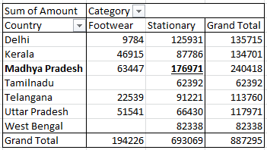

Que.2) What is the total count of stationary bought from Tamilnadu?

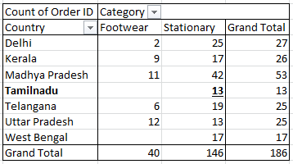Ans. – 13

Que.3) What is the total amount spent on footwear?

Ans. – Rs. 194226/-

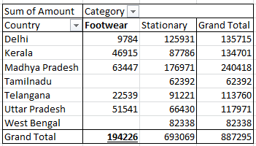



Que.4) What is the total amount of money spent for stationary in July?

Ans. – Rs. 53398/-

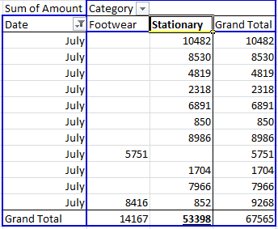

Que.5) What is the count of footwear that is coming from Delhi?

Ans. – 2

